Operating Systems (FORK)

Program 1
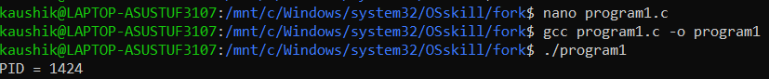
Program 2
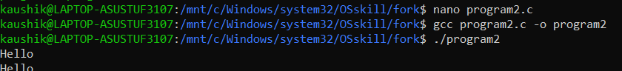
Program 3
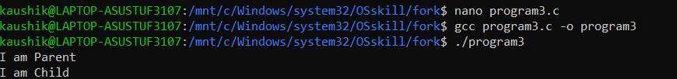
Program 5
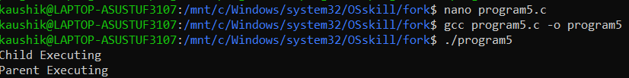
Program 4
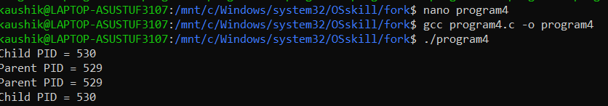
Program 6
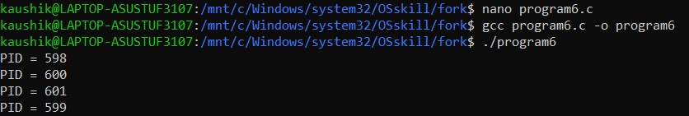

Program 7
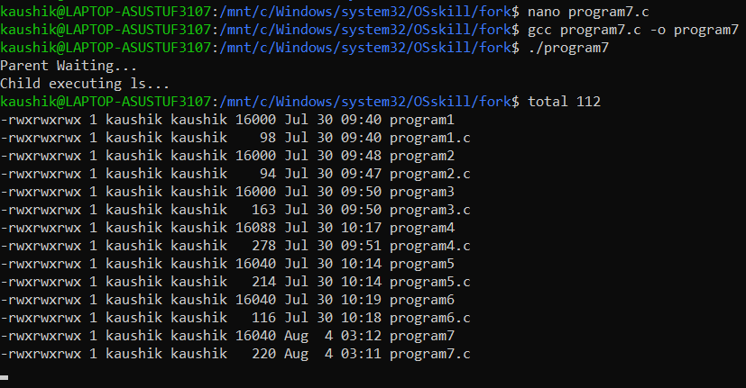
Program 8
